OUM

DO.070 User Guide

Al-Gihaz Holding –ERP

Oracle Projects -

How to enable Project Versioning

|  |  |
| --- | --- |
| **Author:** | Muhammad Daniyal Khurshidi |
| **Creation Date:** | 16–Jun-2016 |
| **Last Updated:** | 16–Jun-2016 |
| **Document Ref:** | AG_UG_PM_ PV |
| **Version:** | v1.0 |

1. **Title, Service Name, Last Updated Date, Reference Number**, **andVersion** are marked by a Word Bookmark so that they can be easily reproduced in the header and footer of documents. When you change any of these values, be careful not to accidentally delete the bookmark. **You can make bookmarks visible by selecting Tools->Options…View and checking the Bookmarks option in the Show region.**

**Approvals:**

|  |  |  |
| --- | --- | --- |
| **Approver** | **Designation / Role** | **Signature & Date** |
| Hassan Mujahid | Raqmiyat Project Manager |  |
| Dr. Tarek Amer | AG Commercial Director |  |
| Ahmed Al Sokkary | AG Project Manager |  |
|  |  |  |

# Document Control

## Change Record

3

| Date | Author | Version | Change Reference |
| --- | --- | --- | --- |
| 16–Jun-2016 | Muhammad Daniyal | V1.0 | No Previous document |
|  |  |  |  |
|  |  |  |  |
|  |  |  |  |
|  |  |  |  |
|  |  |  |  |

## Reviewers

| Date | Name | Position | Signature |
| --- | --- | --- | --- |
|  | Muhammad Daniyal | Project Consultant – Raqmiyat |  |
|  | Hassan Mujahid | Raqmiyat Project Manager |  |
|  | Dr. Tarek Amer | AG Commercial Director |  |
|  | Ahmed Al Sokkary | AG Project Manager |  |
|  |  |  |  |
|  |  |  |  |
|  |  |  |  |

## Objective

This document will demonstrate & illustrate how to enable Project Versioning in Oracle Projects.

## Audience

This manual is prepared for Al-Gihaz Projects Business Cycles. The concerned department is Projects.

## How to use this manual

Through the Contents, the user can see how to enable a project for versioning so that multiple versions can be made & / or new baseline can be made.

As per the Future Process Model document; the users will be focused only on certain topics and transactions as per their role.

**Contents**

1 Document Control 2

1.1 Change Record 2

1.2 Reviewers 2

1.3 Objective 3

1.4 Audience 3

1.5 How to use this manual 3

1.6 How to enable Project Versioning 5

## How to enable Project Versioning

1. Log in to Oracle.
2. Go to Project Billing User – AGC responsibility.
3. Search for your project.
4. After search result appear, open the project.
5. Click on Structure in the Options section & Press the Detail button.
6. Go to the Workplan tab click on Setup link highlighted in **RED** below.

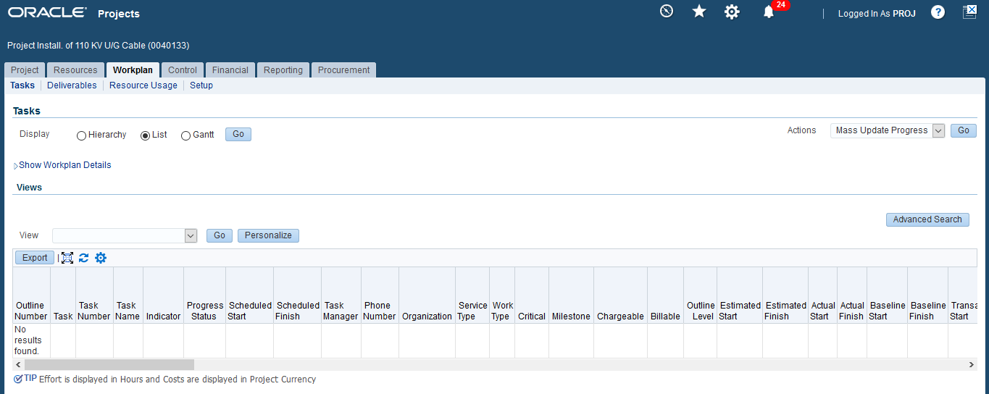

1. Click on Workplan Information link highlighted in **RED** below.

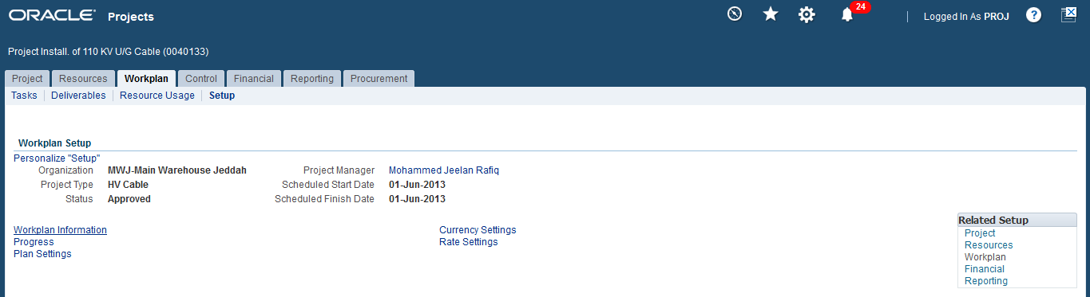

1. Select the check box beside Enable Workplan Versioning highlighted in **RED** below.

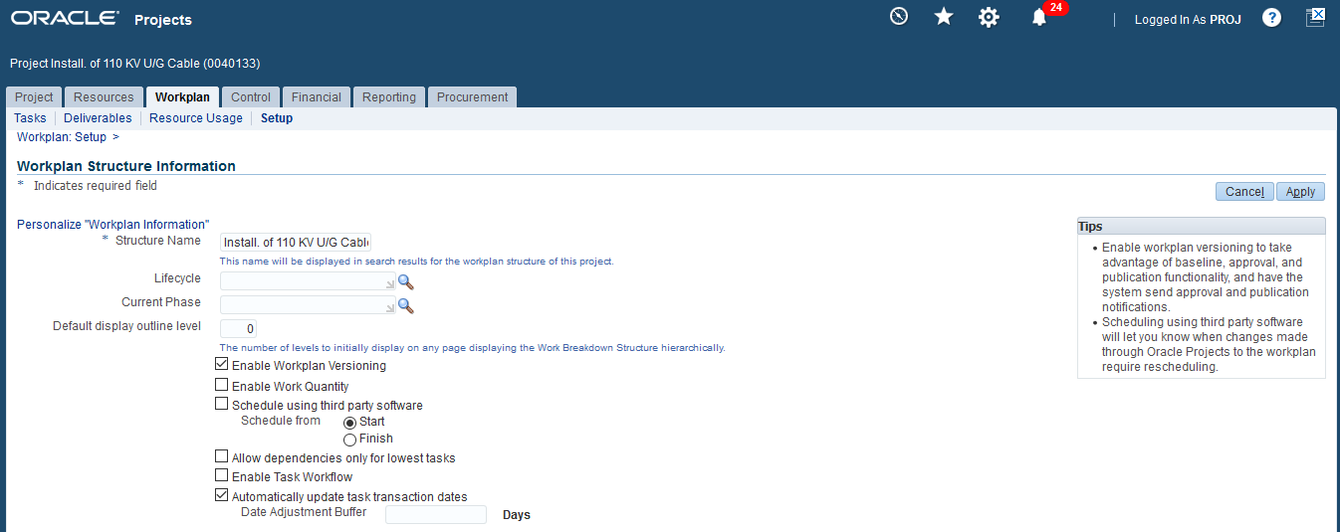

1. Click on the Apply button.
2. Versions of the baseline can be made now.

**NOTE:** Once progressis updated for a project, versioning cannot be turned off.